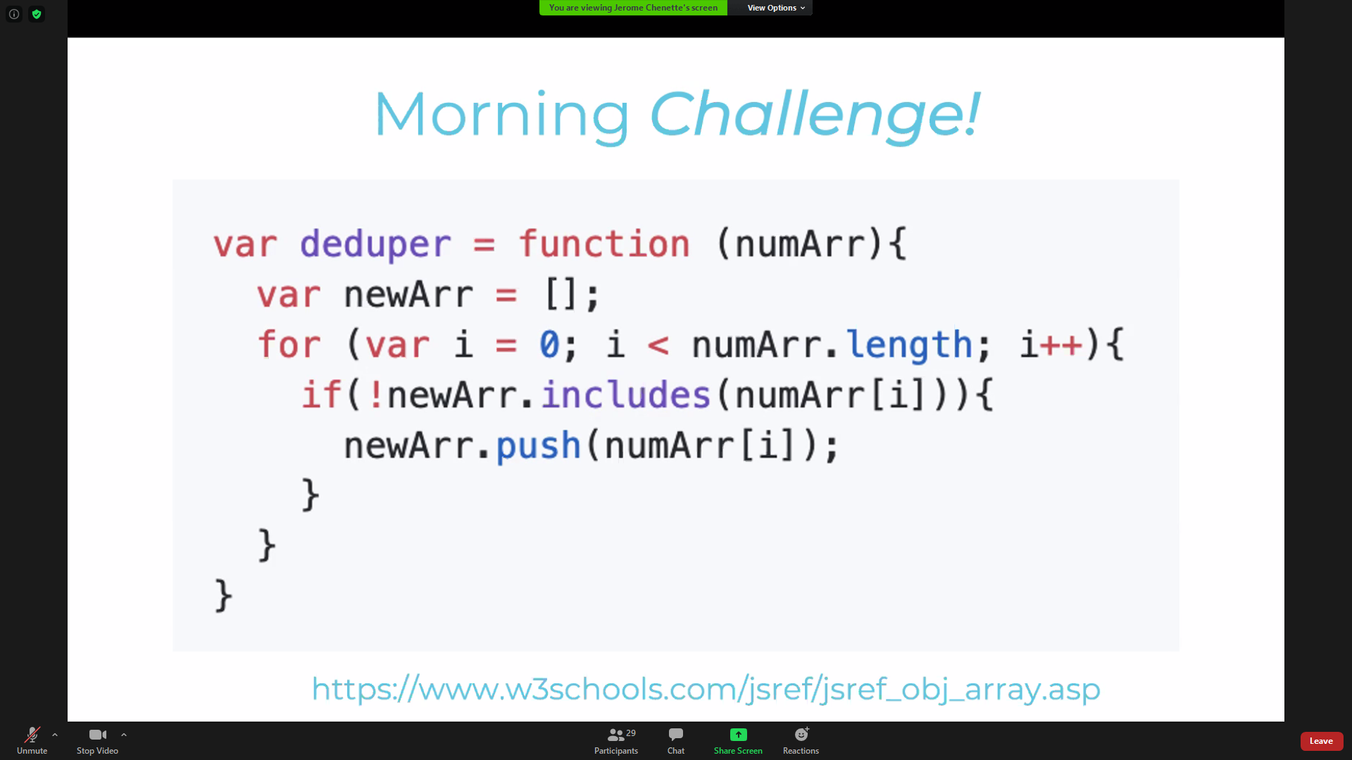

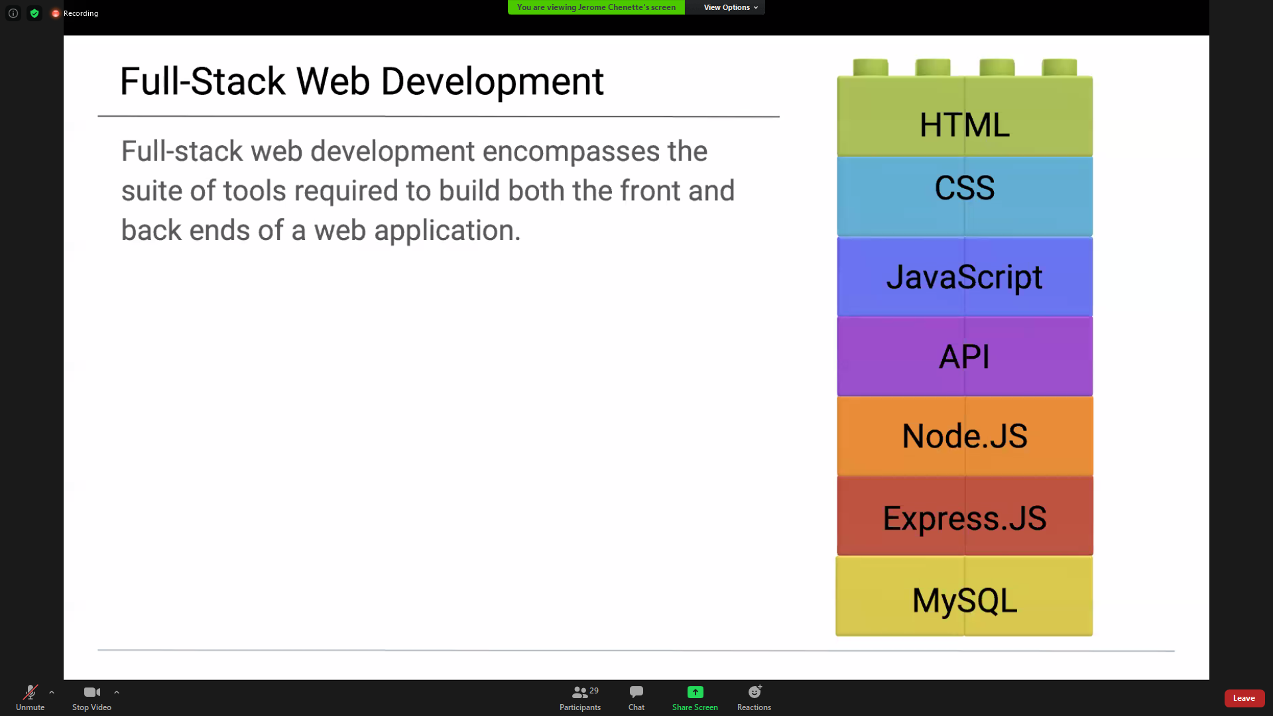

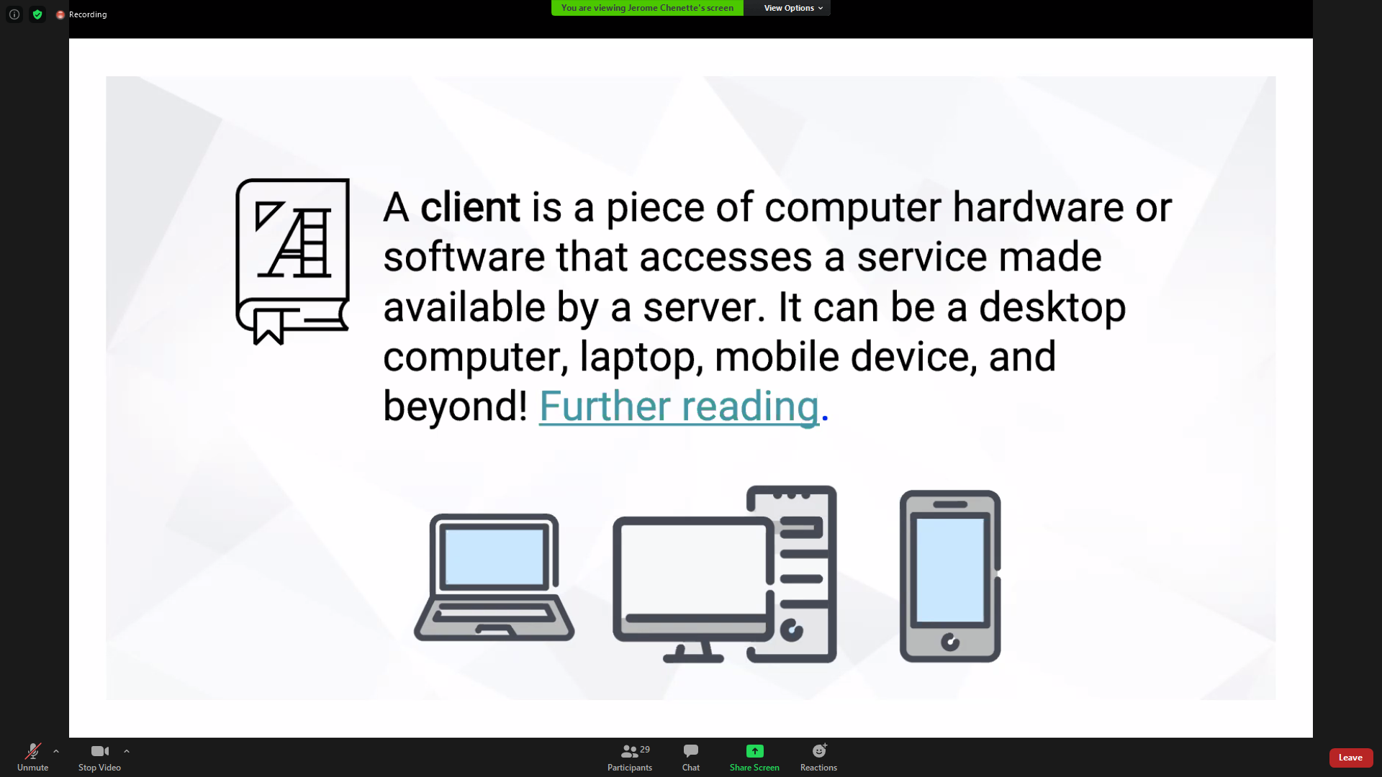

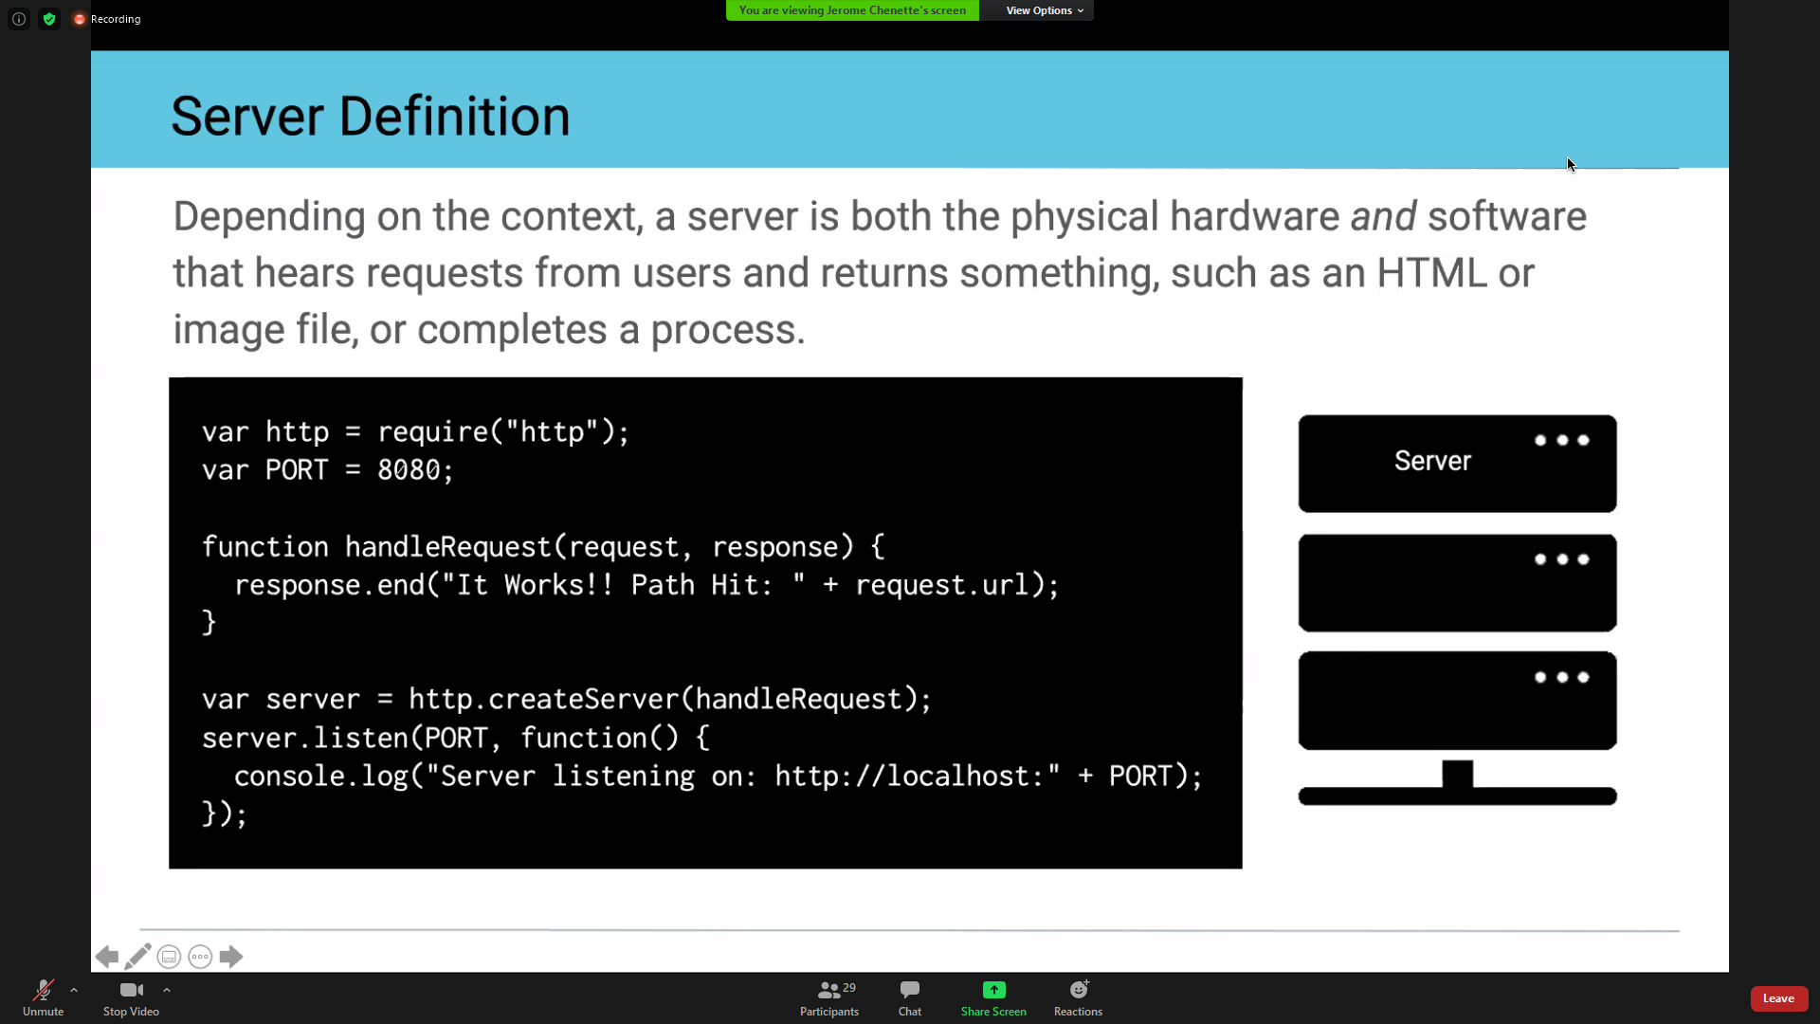

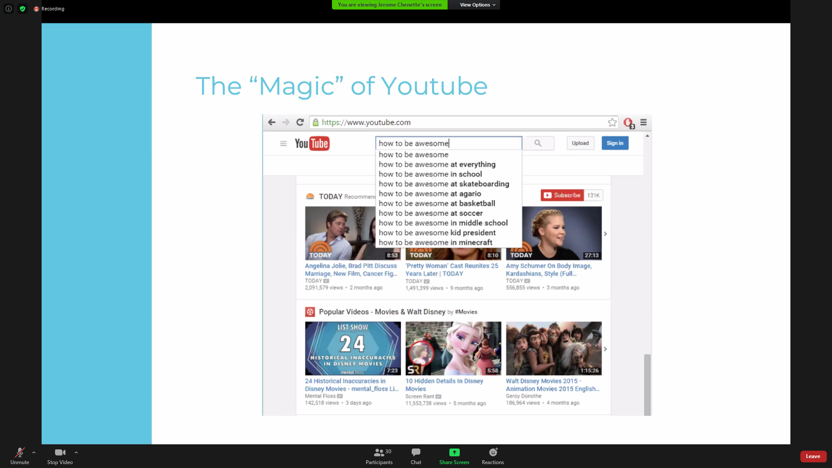

Thinking Prompt / class activity – what would you think of as front end vs back end

YouTube

Front End:

Search bar, nav bar

Initial screen populates DOM with what has been found,

puts objects into cards

sorts by trending

every time user enters a charaxter

Back End:

Takes user input and finds any video content on the web with those search terms

Makes a “get request”

Probably assesses type of info and selects only video, so types of files

On click, screen changes to a screen that focuses on the clicked item

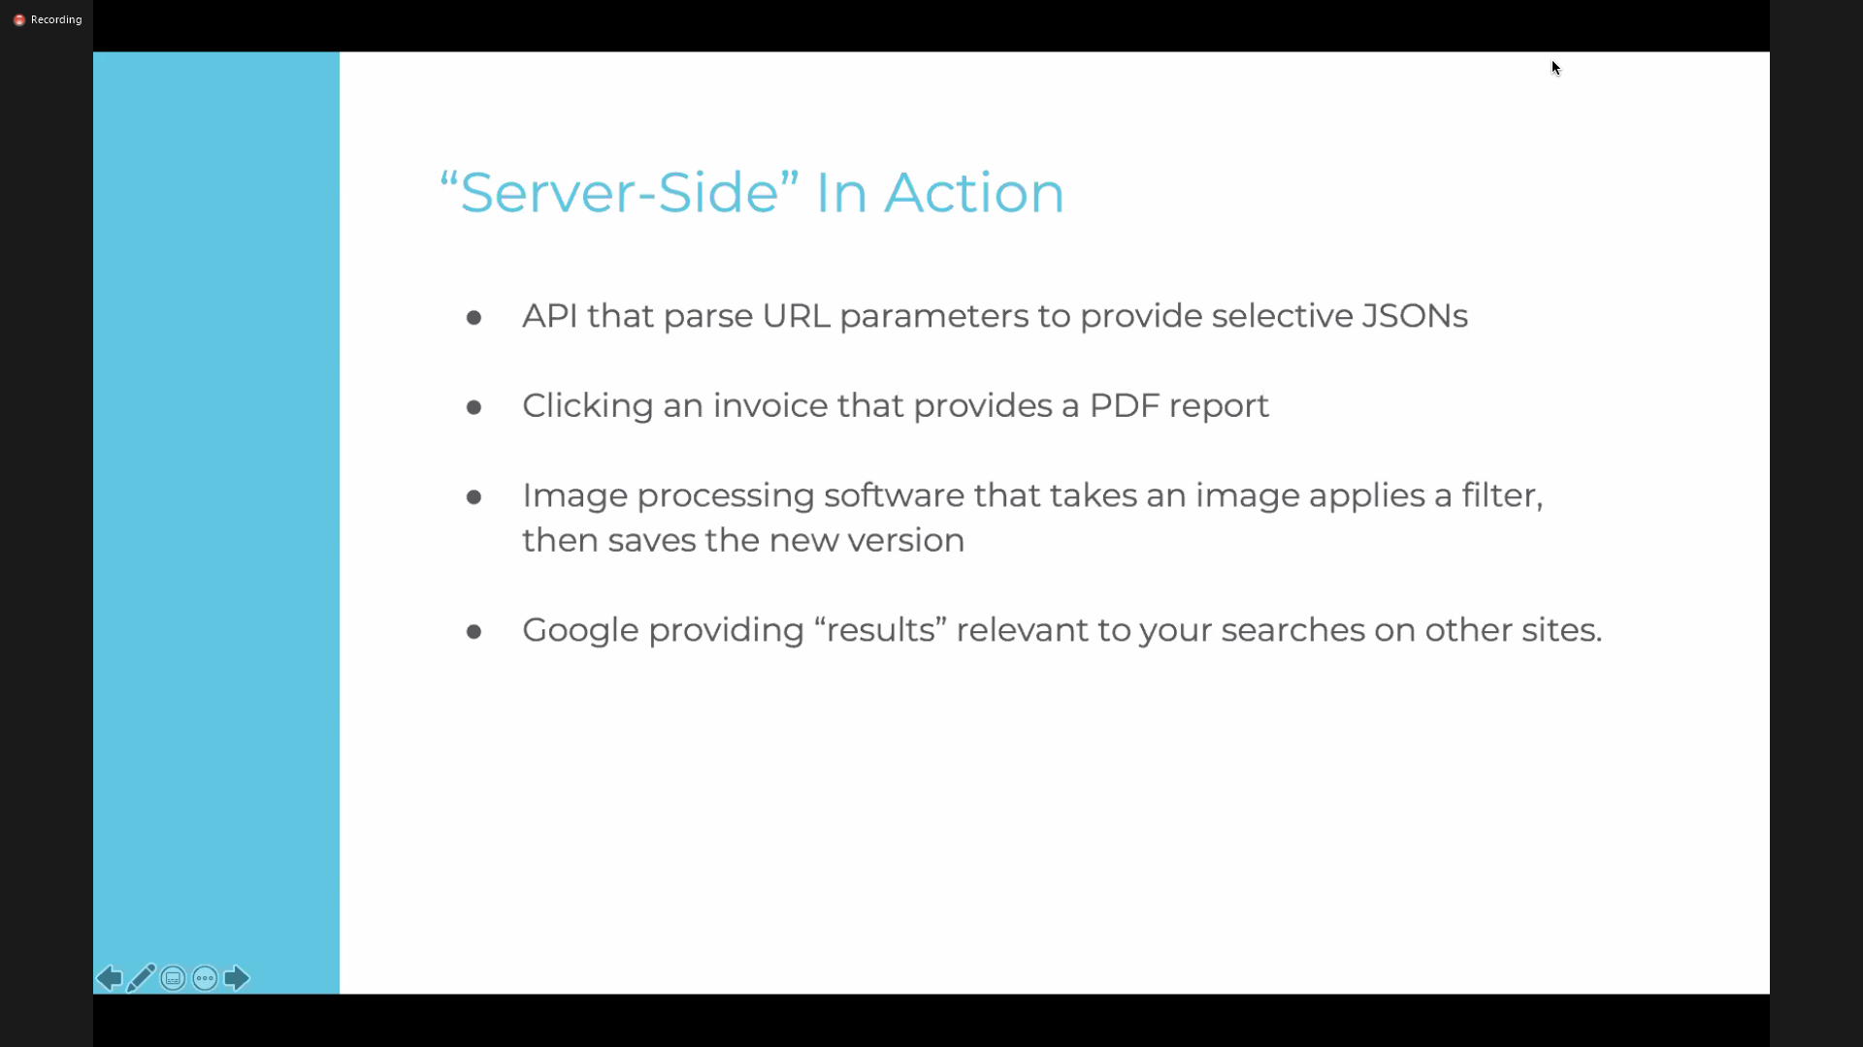

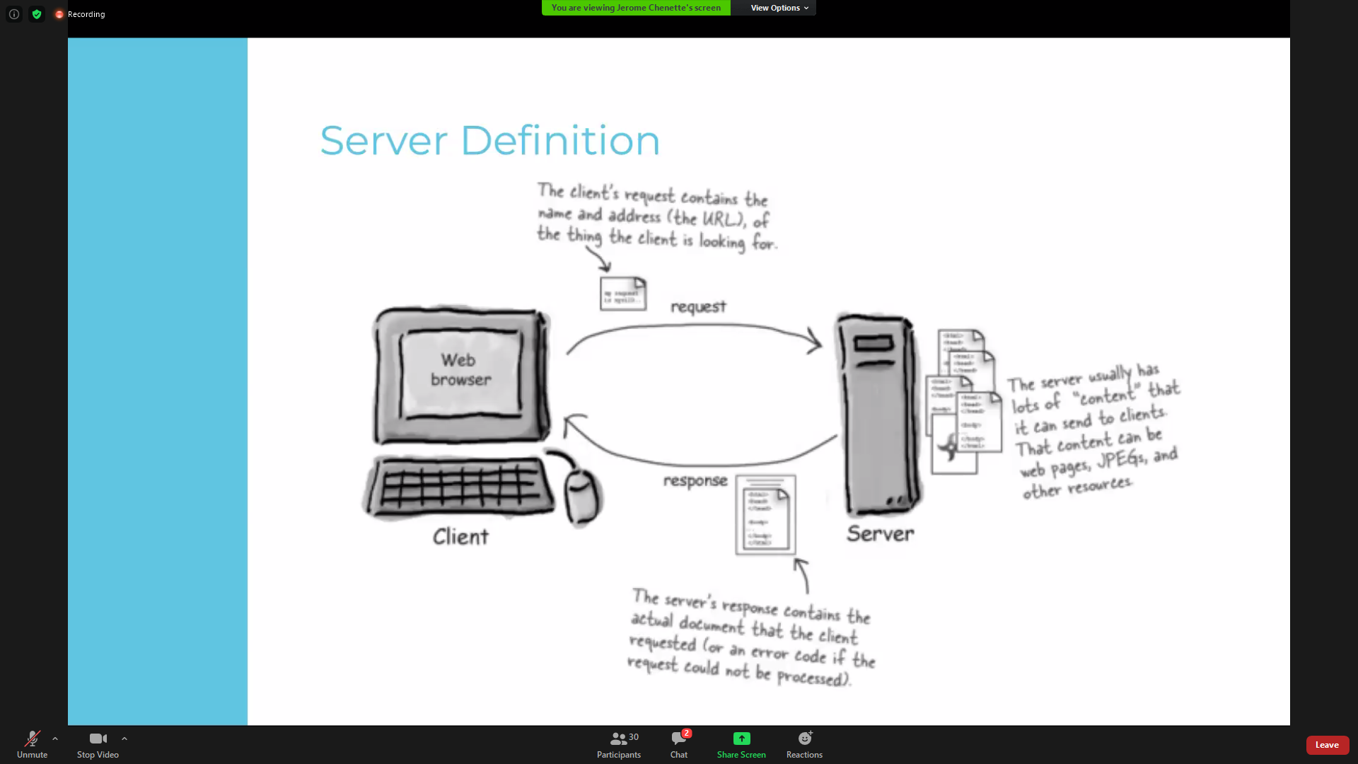

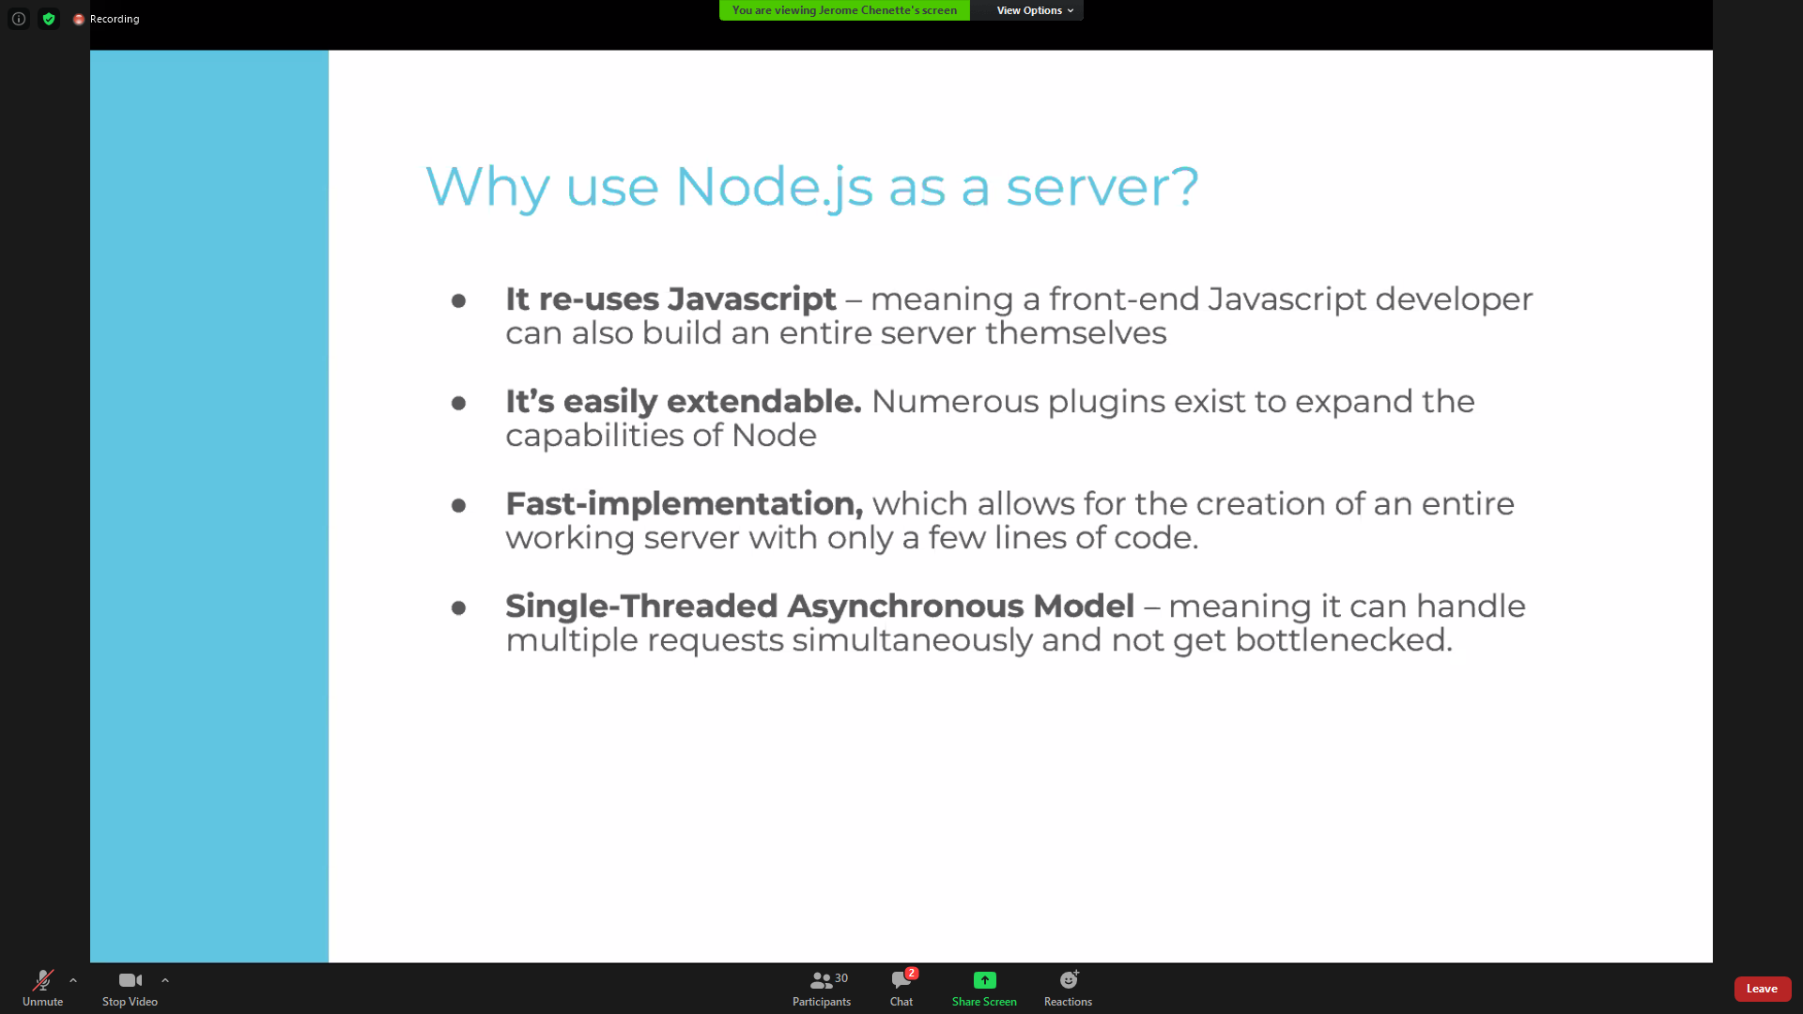

Node.js is asynchronous threading. For comparison, synchronous threading is this:

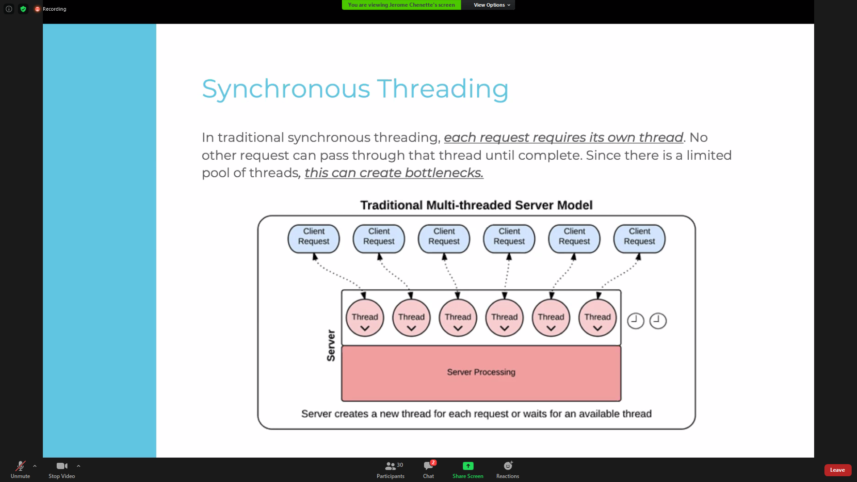

**GET ASYNCRONOUS THREADING SLIDE FROM PPT**

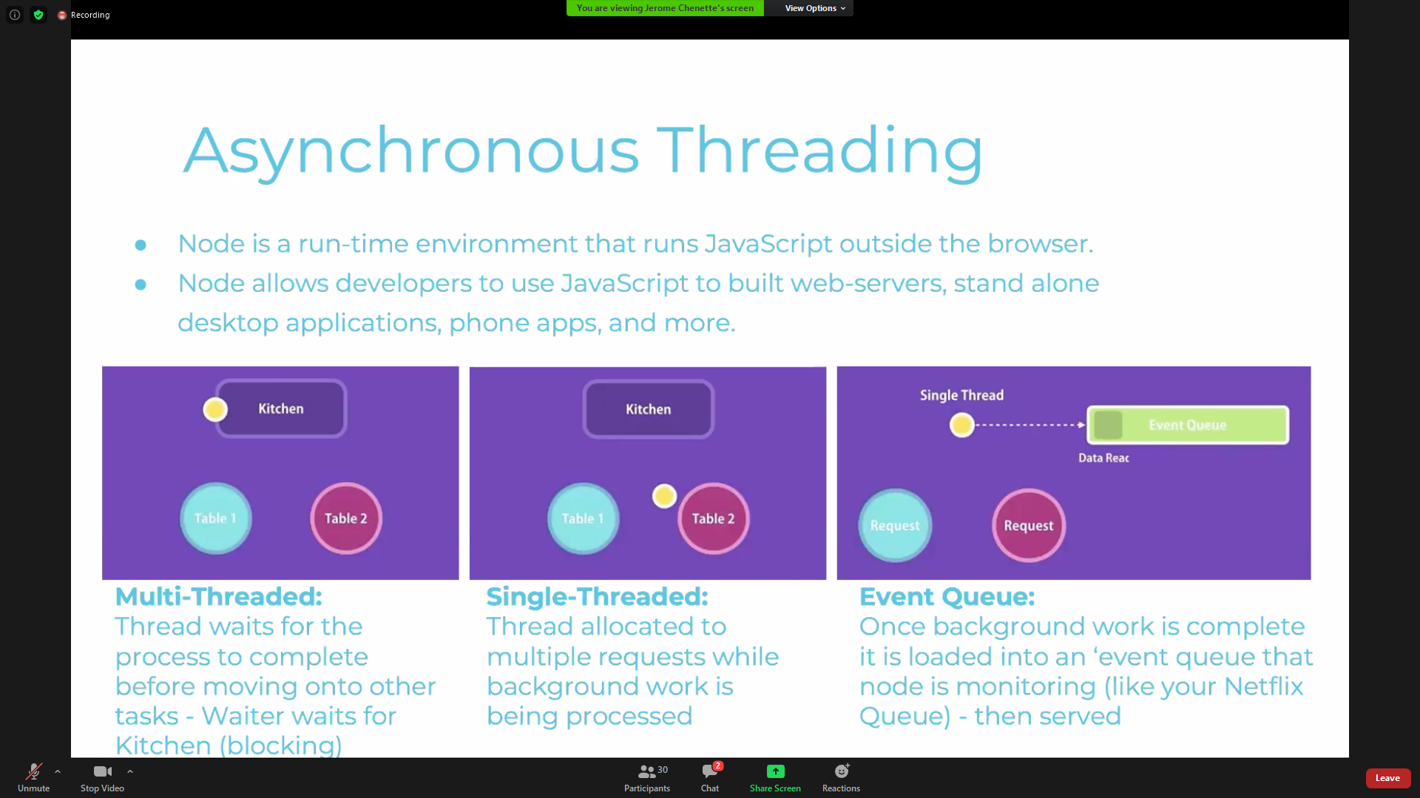

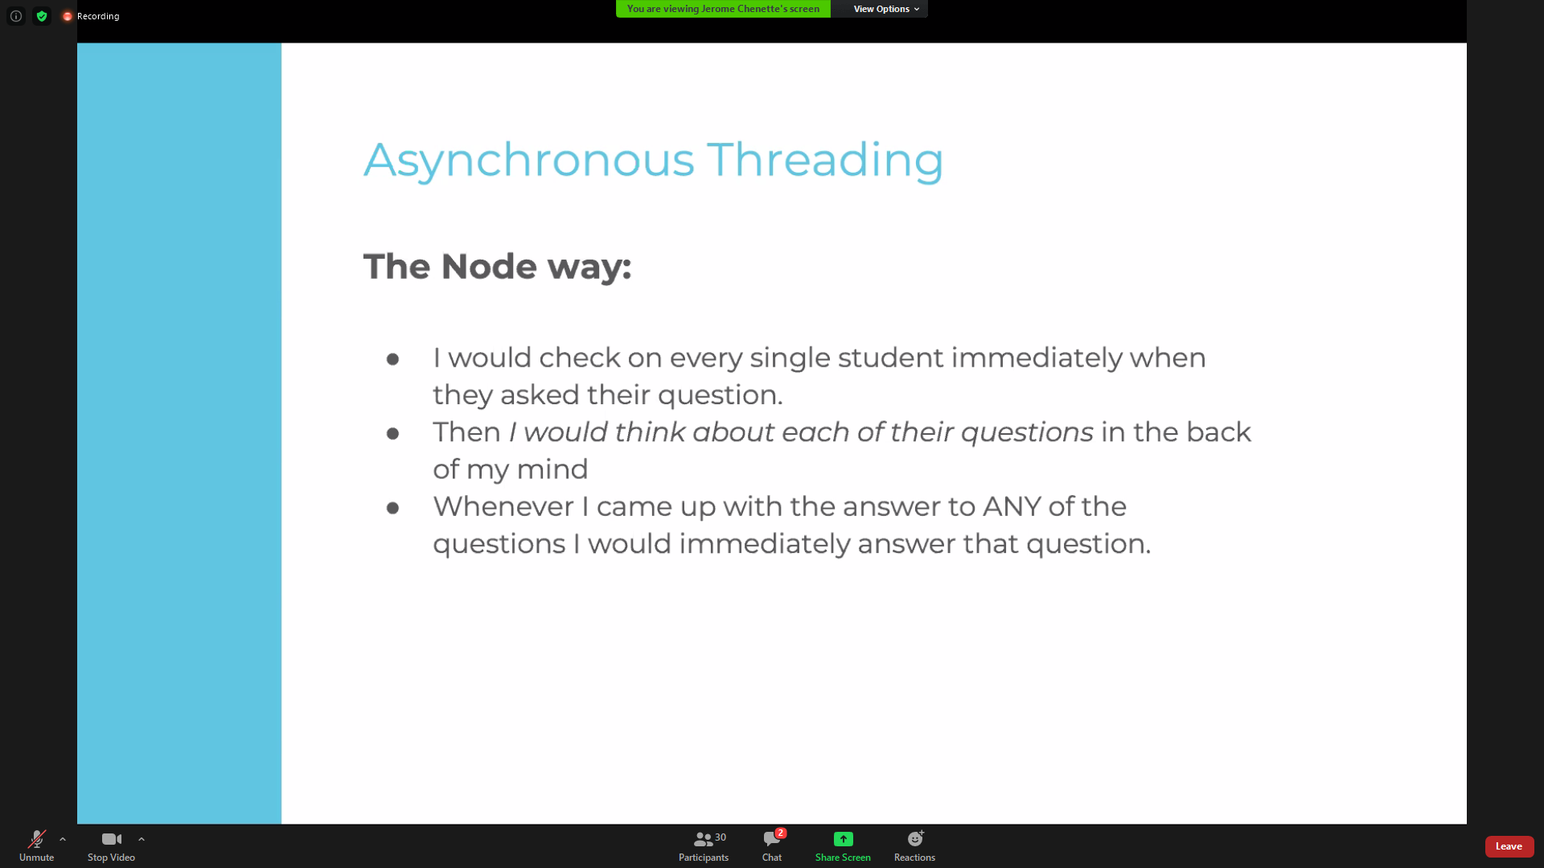

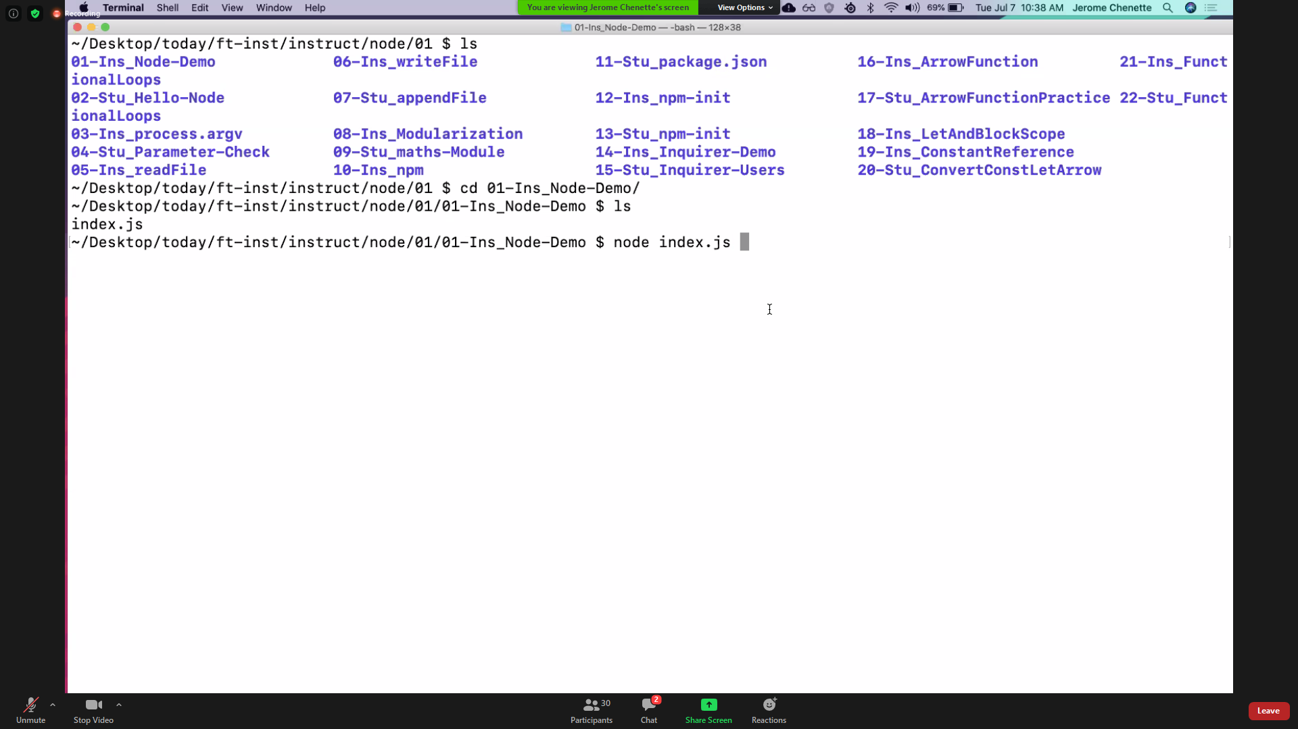

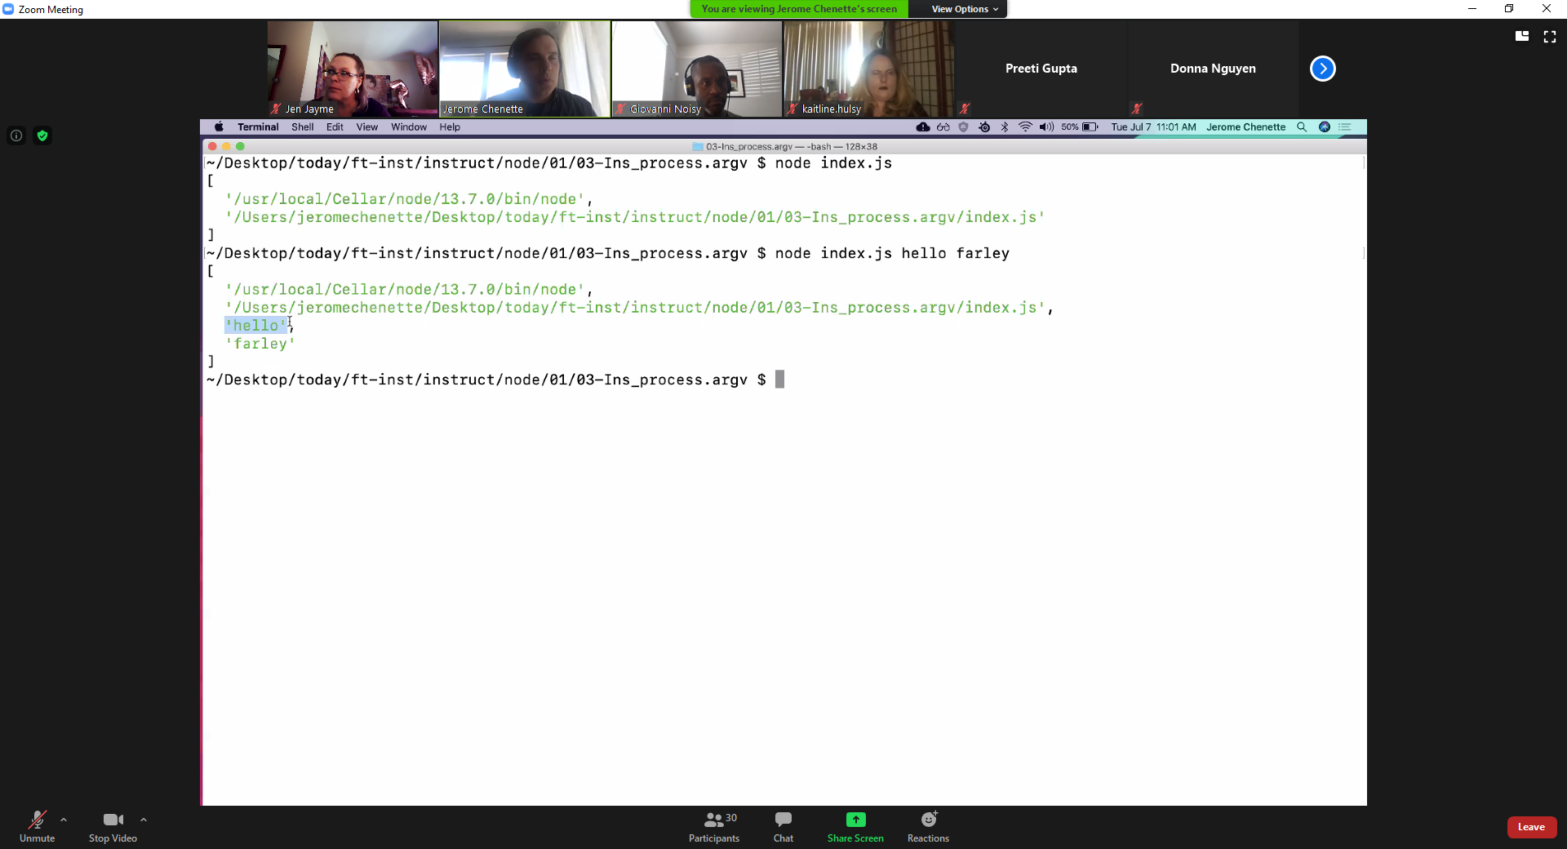

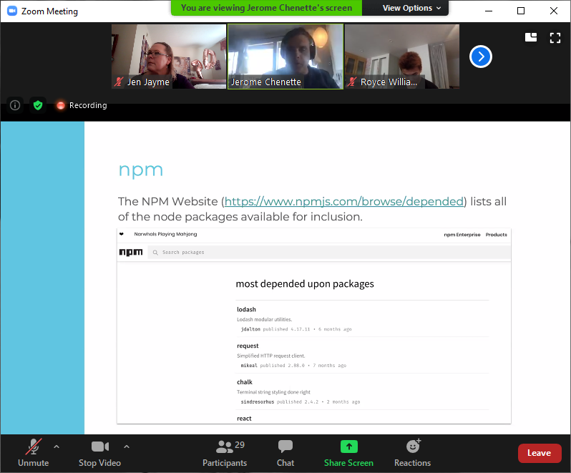

Lodash and axios, are npm packages.